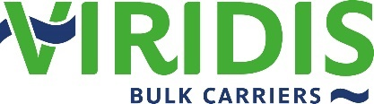
Zero emission short sea bulk logistics

July 1st, 2021 – Farsund, Norway
VIRIDIS BULK CARRIERS PARTNERS WITH 5 SHORT SEA BULK CARGO OWNERS
Ammonia-powered shipping startup Viridis Bulk Carriers have signed MoU’s with cargo owners Elkem, Vestkorn, BioMar, Franzefoss Minerals and Saltimport. Together, the partners will develop an efficient zero emission freight network based on Viridis’ ships and cargo volumes from each Client Partner.
 |  | 
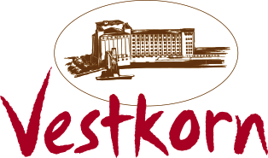 | 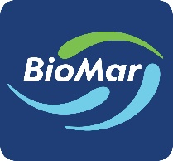 | 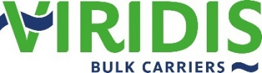

Ammonia-powered ships provide trading flexibility
In addition to further developing the ship technology platform, the partnership will explore a zero-emission logistics system comprising ships, fuel logistics and flows of cargo from the 5 cargo owners. The end goal of the project is a flexible bulk shipping network, served by a fleet of ammonia-powered ships, based on long term contracts of affreightment.
The ships will be sufficiently flexible to handle varying types and volumes of cargo, in terms of both operational range and functional capabilities, while maintaining crew and societal safety at the level of conventional ships. Viridis Bulk Carriers expect to place orders for ships during 2022, with deliveries starting in 2024/25.
Cargo optimization enabling better utilization resulting in lower cost for cargo owners
- We see clear synergies between the cargo flows of our Client Partners. This is a good starting point to achieve high ship utilization, says Espen Nordstrøm at Viridis Bulk Carriers.
With the increased productivity in the logistics chain, the goal is to reduce the cost impact of utilizing carbon free ammonia fuel, which may initially be more expensive than fuels used today. Realization of the project will have a significant impact on local pollutants and global CO2 emissions from shipping, in addition to reducing value chain emissions for food-, fish feed-, metals-, fertilizer-, construction-, and other industries which transport large bulk and special project cargo volumes.
- Elkem is committed to develop its business in support of the ambitions of the UN Sustainable Development Goals and the Paris agreement. As one the world’s leading companies in the environmentally responsible manufacturing of metals and material solutions, we look forward to continue the collaboration with Viridis with the ambition to reduce emissions throughout the supply chain, says Ellen Groeneveld, Managing Director at Elkem Maritime Center.

- As a total supplier of salt products, we are dependent on imports and sea transport. Saltimport has constant focus on innovation and sustainable logistics solutions across our value chain. We have a clear goal to reduce our carbon footprint and offer the most environmentally friendly shipping alternatives for our customers and partners, says Lisbeth Nordal, Dry Cargo Broker at Saltimport.

- BioMar’s focus is to ensure sustainability throughout the entire value chain, from raw materials to slaughtered fish. Enabling reduction of emissions for our logistics is imperative to reach our goals, says Tore Gunnar Wikdal, Director Distribution and Inbound Logistics at BioMar.

- Production of quick lime is a carbon intensive process. At Franzefoss Minerals, we have several active CCS and CCU projects, but we acknowledge that the timeline may be long before commercialization. Therefore, we have intensified our search for other measures that can reduce our overall carbon footprint. A major part of our cargo volume is transported by sea, and carbon free fuels will make a significant contribution, says Nils-Petter Eriksen, Chief Sales Officer at Franzefoss Minerals AS.

- Vestkorn produces plant proteins from peas and beans and is strongly committed reducing our environmental footprint. Sea transport accounts for as much as 30-80% of the CO2 emissions in our value chain, depending on product. Through the collaboration with Viridis and the other cargo owners, we will be able to not only reduce our own CO2 emissions considerably, but also contribute to commercializing zero emission solutions, says Aslak Lie, CEO at Vestkorn.

Environmentally ambitious cargo owners are welcome to join
- We are pleased that Elkem, Vestkorn, Biomar, Franzefoss Minerals and Saltimport have decided to join us in finding a carbon free solution for their logistical requirements. Together, we invite all environmentally ambitious cargo owners to collaborate with us. Zero emission shipping will be enabled through economies of scale, and our door is open for everyone who finds this interesting, says André Risholm at Viridis Bulk Carriers.
For further info:
General inquiries / Media  Karl Arthur Bræin  Tel: +47 9486 1565  Email: kab@amonmaritime.com | Commercial inquiries – Clients  Espen Nordstrøm  Tel: +47 9017 6049  Email: en@navigare.fo | Commercial inquiries - Technology manufacturers  Steinar Kostøl  Tel: +47 9700 5327  Email: sk@amonmaritime.com
Viridis Bulk Carriers is a joint venture between Navigare Logistics, Amon Maritime and Mosvolds Rederi. The joint venture will develop, build and operate zero emission bulk carriers, drawing on the expertise, networks and capabilities of each of the partners.
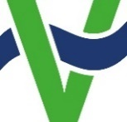

Viridis Bulk Carriers AS | Barbros gate 14, 4550 Farsund, Norway
www.viridisbulkcarriers.com

